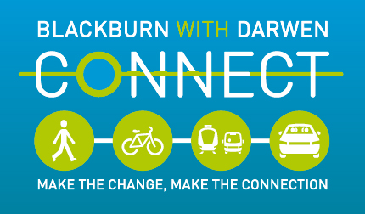

An easy read guide to CONNECT

What does sustainable transport mean?
It means transport that is better for the planet, with less pollution and waste.
Like walking, cycling, catching the bus or the train or car sharing.
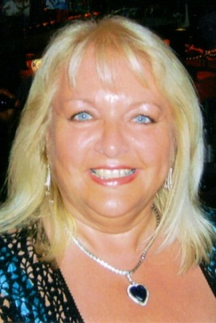 | Cheryl Sandford from the CONNECT Project can help you with transport.  She works in Blackburn town hall.
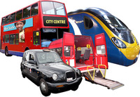 | Cheryl’s job is to help you get to your place of work, interview or training using sustainable transport.
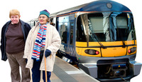 | Or Cheryl can help you plan a day out.
 | Are you going to an interview or starting a new job?
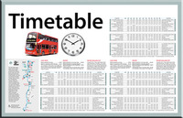 | Cheryl can help you find the cheapest and fastest way to get to interviews, training courses or your new place of work.
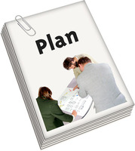 | Cheryl can give you a travel plan. You can have a travel plan to go for a day out or to see your friend, not just to go to work.
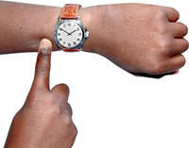 | The travel plan will give you the times for your transport.
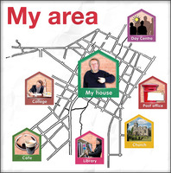 | The travel plan will show you the quickest and easiest way to get to your interview or new job.  If you are planning a day out, it will show you how to get there and how long it will take you.
 | Cheryl could help you to pay your travel costs for going to interviews or starting a new job.
 | There are lots of different ways you can travel.
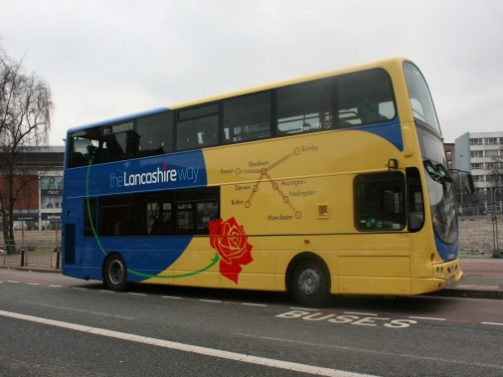 | Bus  There are lots of buses to use in Blackburn with Darwen.  You can buy a travel pass to help you save money.
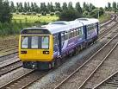 | Train  There are train stations in Blackburn, Darwen, Mill Hill, Cherry Tree, Pleasington and Entwistle.  You can buy a travel pass to help you save money.
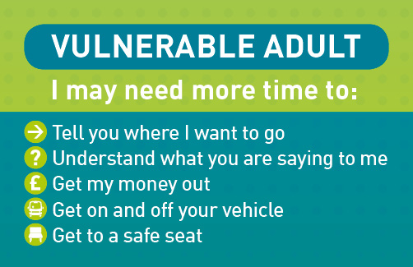 | There is a ‘Vulnerable Adult’ card scheme available.  You can ask Cheryl at the Connect Project for a card. You can use it on public transport to let staff on the bus or train or taxi know that you may need a little more time or patience.  Who can get a card?  Anyone with a learning disability, dementia, physical disability or anyone who feels this would be a good idea to have one.  You must live in Blackburn or Darwen.  How to get a card  You will need to fill out an application form. You can get a form from Cheryl Sandford. How to contact her is written at the end of this leaflet.
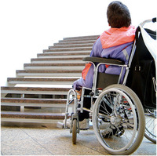 | If you have a physical disability and your local train station isn’t accessible, Northern Rail can transport you to your nearest accessible station.
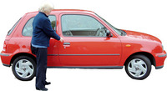 | Park and stride  This is when you park your car and then walk a short distance to work or your destination.
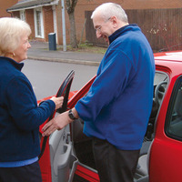 | Car share  If you own a car or even if you don’t, you can join Shared Wheels which brings people together to car share.  Car sharing is when 2 or more people share a car and travel together. They normally share the petrol costs. It means there are less cars on the road.
Walking
Walking helps to keep you fit and healthy.
You could join a walking group.

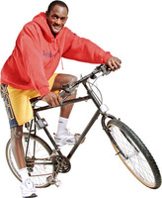 | Cycling  Cycling helps to keep you fit and healthy.  If you want to cycle to work we can give you information about the Cycle to Work Scheme.  This lets you buy a bike and pay the cost back monthly.
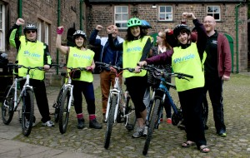 | You can learn to ride a bike or go for a ride on a bike in Witton Park.  There are different types of bikes you can borrow and someone will ride with you. This is free.
 | If you want to find out more about how CONNECT can help you contact Cheryl Sandford.
You can ring Cheryl on

01254 588814

or email

cheryl.sandford@blackburn.gov.uk

