CASE STUDY
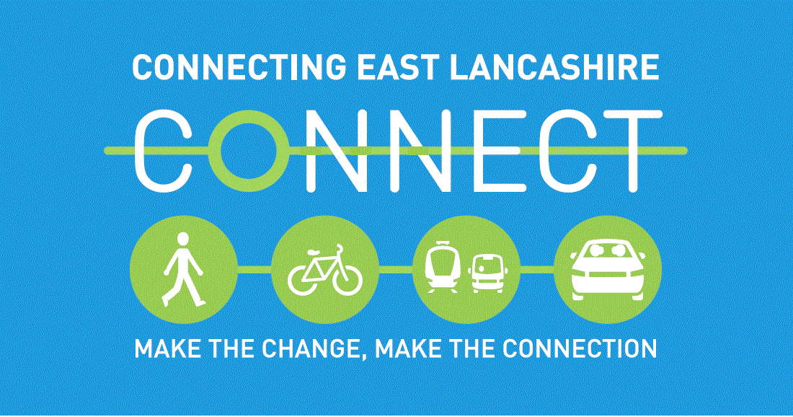 ROYAL BLACKBURN TEACHING HOSPITAL

Title | Electric Bike Ride Experience as part of the Active Sustainability Day
Date | Thursday 4th October 2018
Name and Department | Deborah Harrison Orthodontics
Was this your first time on an Electric Bike?
“Yes – although I do own a bike, I am quite inexperienced”.
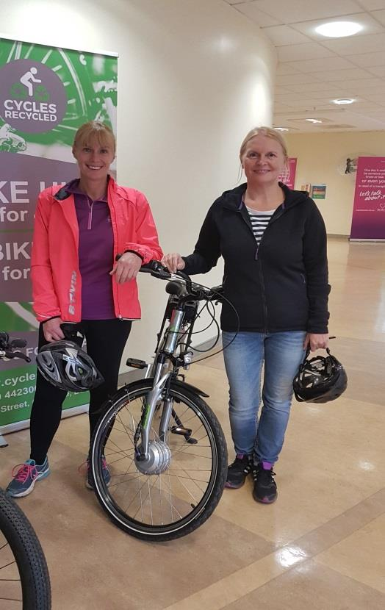
How would you rate Ian your Ride Leader?
“Ian who brought the bikes and led the ride was friendly, knowledgeable and mindful of our inexperience with an electric bike. He made it fun and he was incredibly kind and approachable. 10 out of 10 for the bike ride and for Ian too, I can’t praise this highly enough”.

What did you personally enjoy about the Electric Bike Ride Event?
“I loved this initiative!!!! I thought it was well thought out, well organised and really considered the health of ELHT Staff”.

How did you find the experience of riding an Electric Bike?
“The Electric bike was not complicated to use and I took to it with ease considering that I had never used one before. I was nervous at first but Ian (Ride Leader) was reassuring and put us both at ease. The initial nerves soon faded and once we were off I was filled with excitement and it was really fun. The length of the ride was perfect to get a feel of the bike and we are looking forward to riding one again”.
How likely is it that you would recommend the Led Ride to a colleague?
“We have been telling everyone in our department about this initiative and found that everyone we have spoken to were interested in it”.

